Subscription Shared Parameter Loader

This add-in is designed to save time while loading shared parameters into a Revit document. There is a free version of this utility, but does not support filtering or family documents.

Contents

The User Form 1

Subscription Version 2

Free Version 2

# The User Form

The user form contains options to load in a selected shared parameter file along the top. All parameters in the shared parameter file are then displayed along the left and can be shown grouped by either their assigned group name or their data type. Categories are shown along the right. There is no limit to the quantity of parameters that can be loaded on a single step, but the selected parameters and their group under association must be supported by the target document.

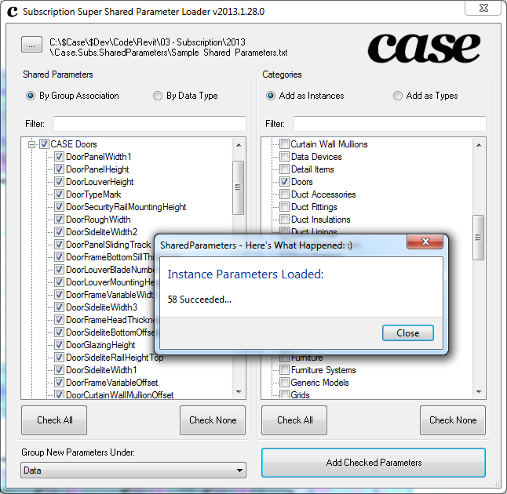

## Subscription Version

The subscription version supports family files as well as the means to filter for parameters by name as well as categories by name.

## Free Version

The free version can only be used on project models and will not function in a family document environment.